*Florida International University*

*School of Computing and Information Sciences*

Software Engineering Focus

Interactive Paint

User Story ID <306>

**Name:**

Jim Louro

**Team Member(s):**

Daniel Mederos

**Project:**

Interactive Paint

**Product Owner(s)**:

Francisco Ortega

**Mentor(s)**:

**Instructor**: Masoud Sadjadi

**User Story Name:** Create Rectangle Shape

* Description: As a Developer I would like to create an rectangle so that it can show up in the GUI Canvas

**Acceptance Criteria**

* The Rectangle should be able to be created on the GUI canvas (Devices we currently own)
* The dropdown menu with the eclipse button should be presented to the user
* The eclipse button in the dropdown menu when clicked should draw an eclipse when you click on the GUI Canvas

**Use Case** Create an Rectangle shape in the GUI Canvas

|  |  |  |
| --- | --- | --- |
| #**344** Create Rectangle Shape | | |
| ***Description*** | When the user clicks on the rectangle button, the user should then be able to draw an rectangle when he clicks on the GUI canvas | |
| ***Actor*** | User of Interactive Paint | |
| ***Precondition*** | GUI must be running | |
| ***Flow of Events*** | **User** | **System** |
| **1.** | User clicks on Brush button | A dropdown menu appears and the rectangle button appears |
| **2.** | User clicks on rectangle button | The mouse pointer is now active with the rectangle function |
| **3.** | User clicks on the GUI Canvas | A small rectangle appears and reshapes itself when the mouse pointer moves away from the point of the initial click |

**Use Case Diagram**

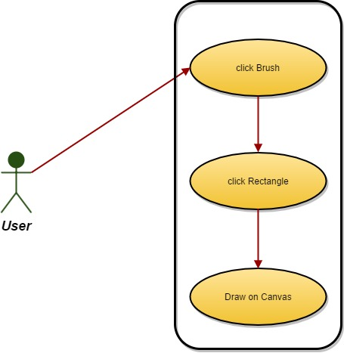

**Sequence Diagram**

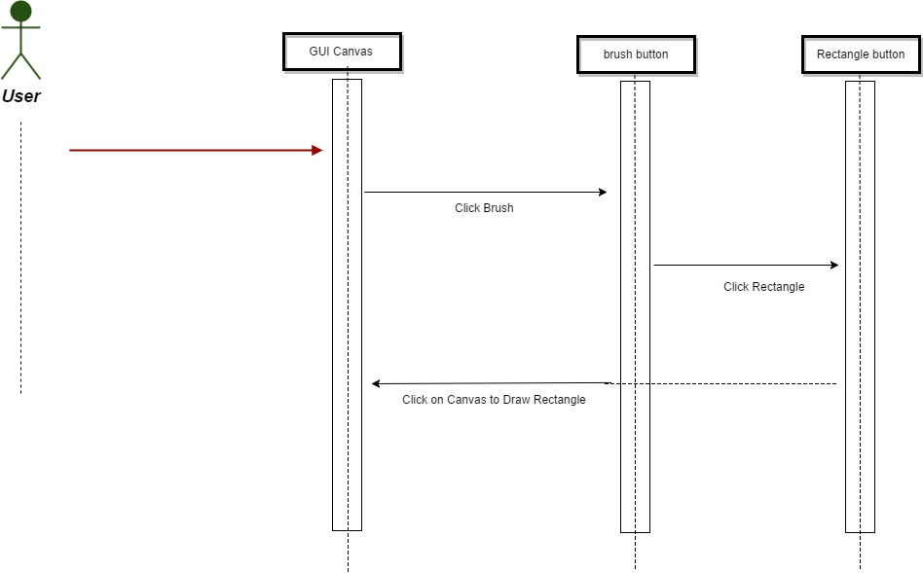

**Class Diagram**

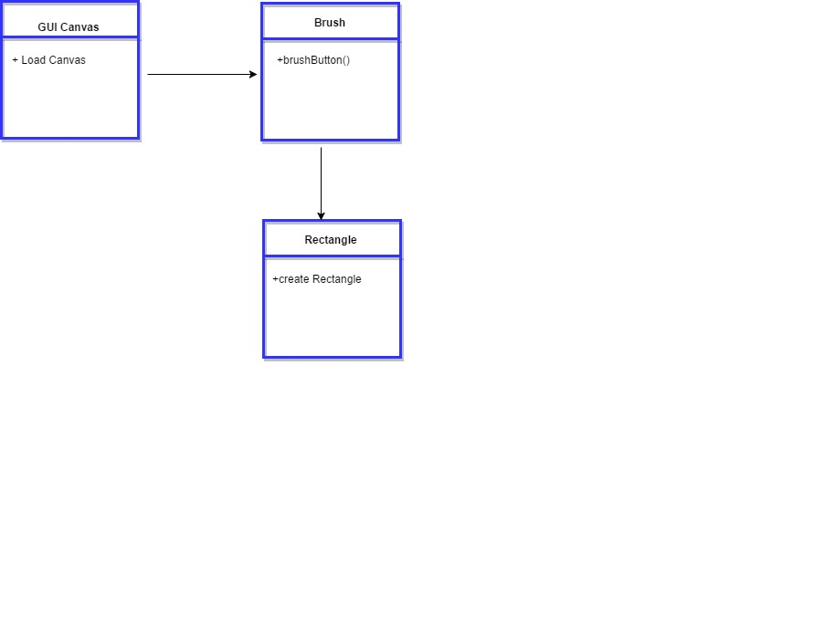

**Integration Test**

**Testing**

**Description:**

* Test the rectangle button and lets the user draw an rectangle on the GUI canvas

**Work Log:**

**Unit Test**

**Test Case 1 (sunny)**

***Purpose:*** to test that the rectangle button appears when user clicks on brush button

* Precondition The user must have QT plugin for visual studio and must run the program
* Input: User clicks on brush button which then a drop down menu appears
* Expected Result: Rectangle button appears on GUI Canvas from a drop down menu
* Actual Result: Actual result was found to be the expected result.
* Status: **PASSED**

**Test Case 2 (sunny)**

***Purpose:*** to test that the rectangle button properly lets the user draw an rectangle on the GUI Canvas

* Precondition The user must have QT plugin for visual studio and must run the program
* Input: User clicks on brush button which then a drop down menu appears and must click rectangle
* Expected Result: Rectangle appears on GUI Canvas and is finally cemented when user clicks on another area of canvas
* Actual Result: Actual result was found to be the expected result.
* Status: **PASSED**

**Test Case 3 (rainy)**

***Purpose:*** to test that the rectangle button appears when user clicks on brush button

* Precondition The user must have QT plugin for visual studio and must run the program
* Input: User clicks on brush button which then a drop down menu appears
* Expected Result: Rectangle button appears on GUI Canvas from a drop down menu
* Actual Result: Actual result was found to be the expected result.
* Status: **PASSED**